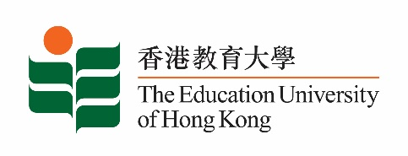
致： 傳媒機構採訪主任 (共 1頁) 20 May 2022
To : News Editors (total: 1 page)

香港教育大學2022年5月23日至6月5日可供採訪之活動一覽
The Education University of Hong Kong (EdUHK) Events Calendar for 23 May to 5 June 2022
本校誠邀 貴機構派員採訪下列活動。傳媒查詢，請聯絡教大傳訊處（電話：2948 6050）。
You are cordially invited to cover the events below. For media enquiries, please contact the Communications Office at 2948 6050.

因應2019冠狀病毒疫情，以下活動或有人數限制，傳媒請預先向主辦部門登記。
In light of the COVID-19 pandemic, there may be restrictions on the number of participants for the following event(s). Please contact the respective organiser(s) / department(s) for prior registration.

日期  Date | 時間  Time | 活動  Event | 地點  Venue | 主辦部門及公眾查詢  Organiser &  Public Enquiry | 備註  Remarks
2022-06-01 –  2022-06-17 | 平日：  Weekdays:  12 noon – 7 pm  週末及公眾假期：  Weekends and Public Holiday: 11 am – 8 pm | 「西油記」社區藝術展覽  “Journey to West Kowloon” Community Art Exhibition | 西九文化區藝術展亭  Arts Pavilion, West Kowloon Cultural District | 主辦部門 / Organiser:  文化與創意藝術學系  Department of Cultural and Creative Arts  香港旅遊發展局  Hong Kong Tourism Board  查詢 / Enquiries:  何暘博士Dr Sunnie He Yang  電話 / Tel :  2948 8360 | 詳情/ Details:  https://www.discoverhongkong.com/eng/what-s-new/events/detail.id78612.-%E8%A5%BF%E6%B2%B9%E8%A8%98-%E8%97%9D%E8%A1%93%E5%B1%95%E8%A6%BD.html

